##### Magnetic Calendar

**Price: Rs.800/-**

Magnetic table calendar new style best for office use.

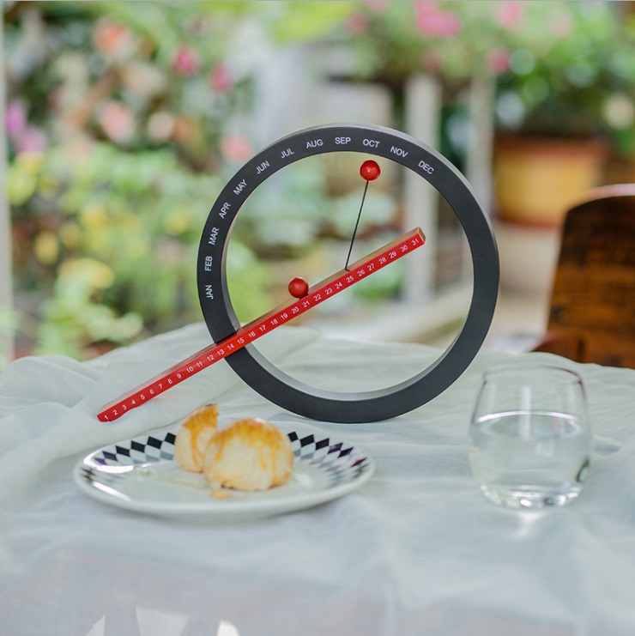

* Model Number: 2078581119
* Type: Printing Calendar
* Promotional: No
* Style: Table Calendar
* Display Screen: show as the picture
* Use: wood calendar
* Origin: Japan
* Color: Show as the pictures
* Size: 20.5cm x 20cm x 5cm
* Type 1: Table Calendar
* Type 2: Wooden Calendar